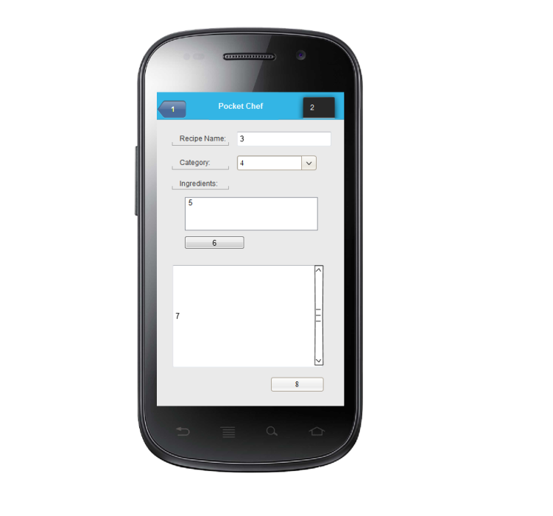

For the **Add Recipe** page, it starts off pretty basic. Buttons the top of the screen consists of the **Back** button **(1),** and the **Menu** button **(2)** which will help navigate through the pages**.** The following is the adding of **Recipe Name** which the user can type at **3**.After that you may a select a **Category (4)** of the type of recipe it is (Appetizer, Dessert, or Entrée). We get to **5** which are the **Ingredients** input, the user can type up the name of the ingredients used in this recipe and the amount. The Add **Ingredient** button **(6),** allows the user to add another ingredient to the list and create a new list like the one for **5**. The next box the user gets to is the **Description (7),** which allows the user to input a description of the recipe and a step by step guide to making it. When the user is completely finished, the user clicks the **Done** button **(8).**

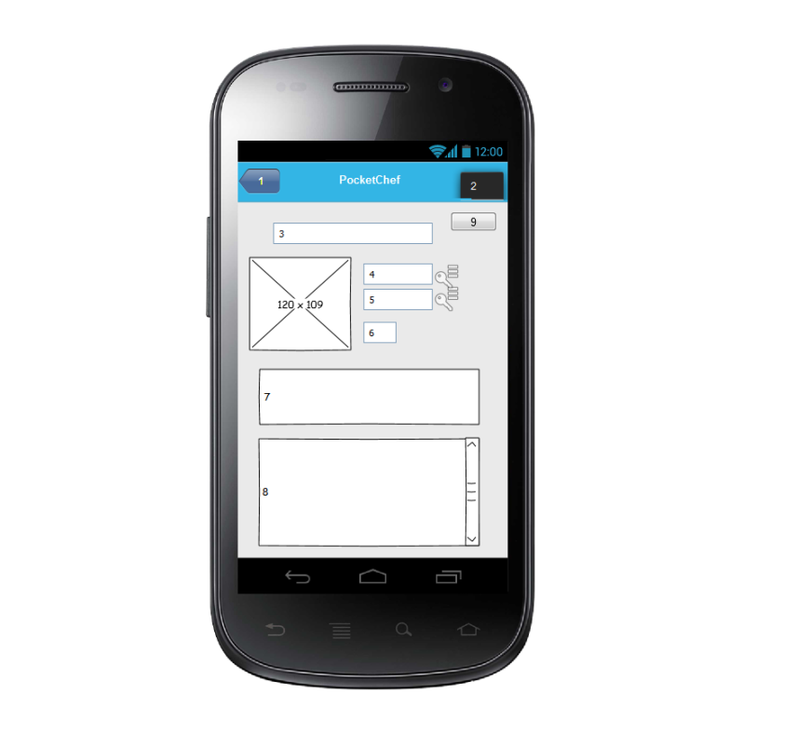

For the **Item Pages** page, it starts off pretty basic. Buttons the top of the screen consists of the **Back** button **(1),** and the **Menu** button **(2)** which will help navigate through the pages**.** The first text box **(1)** shows the **Name** of the item being searched. Bellow it there are other text boxes, the first one **(4)** being the **Purchase date** of the item. Next to it is an android icon where a **calendar** will be, this will allow a full calendar to pop up showing the date of which the item was bought. The next text box **(5),** is the **Expiration date**, this shows when the product is set to expire. Next to it is another **calendar** android icon which will show the date on the calendar when the product will expire. The next text box **(6)** shows the **quantity** of the item the user has in their inventory. Boxes 4-6 are located right next to the **Picture** of the item. The final text box **(7)** shows a **description** of the item. The bottom of the screen **(8)** shows **recipes** the user has that the item is used for as well as **popular recipes** that users make with the item. Finally back to the top button **(9)** which is the **Edit button**. This will allow the user to manually change the information of boxes **3-7** also the **picture.**